Please select one:
Nor1 Services Request Form

RESPONSE REQUIRED
Please complete and return this form to nor1sales_ww@oracle.com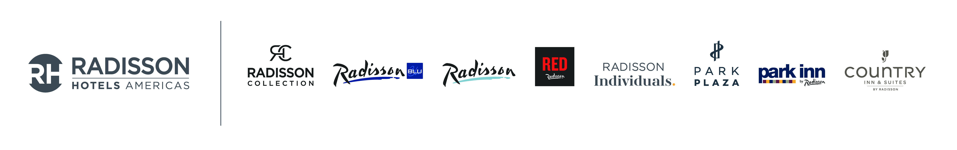es_ww@oracle.com

☐ YES, my hotel would like to implement Nor1’s solutions (check all that apply). Please send me a Participation Agreement. By indicating “Yes”, I understand that my hotel must abide by the terms agreed upon by Radisson Hotel Group and Nor1, Inc.

☐Nor1 eStandby Room Upgrade ☐Nor 1 Checkin Merchandising Room Upgrade
☐Nor1 eXpress Room Upgrade

☐ MAYBE, but I need more information. Please have a Nor1 representative contact me to answer any questions that I may have.

Required Property Information
Property Name: | Enter Property Name | Main Phone Number: | Enter Phone No.
Property Legal Entity Name: | Enter Legal Entity Name | Fax Number: | Enter Fax No.
Property Code: | Enter Property Code | Number of Room Categories: | Enter No. of Categories
Number of Rooms: | Enter No. of Rooms | General Manager’s Email: | Enter Email
General Manager’s Name: | Enter Name | Director of Revenue’s Email: | Enter Email
Director of Revenue’s Name: | Enter Name | Director of Front Office’s Email: | Enter Email
Director of Front Office’s Name: | Enter Name | Respondent’s Email: | Enter Email
Respondent’s Name: | Enter Name | Respondent’s Phone Number: | Enter Phone No.
Respondent’s Title/Position: | Enter Title | Date: | Enter Date
Notes/Comments:

